|  |  |
| --- | --- |
|  | **BURLESON COUNTY**  Elections Administration  **100 W. Buck St., Suite #107, Caldwell, TX 77836**  **Tel:** (979) 567-2000 **Email: electadmin@burlesoncounty.org** **Fax:** (979) 567-0789 |

**ELECTION WORKER INFORMATION**

Thank you for your interest in serving as an election worker. The Burleson County Elections Administration Department is constantly seeking individuals to assist in conducting Ballot by Mail, Early Voting, and Election Day voting. Below you will find a short job description of each position an Election Worker may be assigned to and job requirements for serving as an election worker. If, after reading the job description and job requirements, you are still interested in serving as an Election Worker, please complete the attached Election Worker Application.

**JOB DESCRIPTION (Varies by Position):**

♣ **Presiding Judge:** Responsible for the overall conduct of voting at the polling place, handles all paperwork, assist voters, organizes team on Election Day

♣ **Alternate Judge:** Assists Presiding Judge with any tasks assigned, assist voters, serves as Presiding Judge if the Presiding Judge is unable to perform duties on Election Day

♣ **Clerk:** Assists voters, works with Presiding Judge and Alternate Judge with tasks assigned on Election Day

♣ **Early Voting Lead Clerk:** Same description as Presiding Judge, but works within the time period of Early Voting and reports directly to Elections Administrator

♣ **Early Voting Clerk:** Same description as Clerk, but works within the time period of Early Voting, and works with Early Voting Lead Clerk on tasks assigned

♣ **Office Clerk:** Works in Elections Office, assist Elections Administrator performing clerical duties such as answering phone calls, data entry, preparing supplies for Early Voting and Election Day, works prior to the start of Early Voting and continues until after Election Day

♣ **Ballot Board:** Counts Ballots by Mail, verifies voter signatures, reviews provisional ballots, works sometime after the close of Early Voting through Election Day and may need to come in after Election Day to review late ballots and provisional ballots

**JOB** **REQUIREMENTS:**

♣ Excellent interpersonal skills in order to interact, cooperate, and deal effectively with coworkers, voters, poll watchers, electioneers, and the public.

♣ Strong verbal and written communication skills and basic computer skills and/or familiarity with technology.

♣ Ability to read, comprehend and follow Texas Election Laws and instructions given by the Burleson County Elections Administrator.

♣ Attention to detail and ability to recognize election issues and promptly report any issue to the appropriate person.

♣ Occasionally lift and carry objects weighing up to 45 pounds (e.g. election equipment, ballots, supply boxes, etc.).

♣ Ability to work long shifts, weekends, and rotating schedules and ability to stand and sit for extended periods of time.

♣ Ability to travel to polling locations.

♣ Be a registered voter in Burleson County and pass a background check.

Attached is our poll worker application which we ask that you complete and mail back to us. This information will be provided to the party chair(s) for consideration when they give us their list of workers.

Please be advised that as of 2019, all poll workers who work the County Elections are required to take the online poll worker training. You will find information on our website @ https://www.co.burleson.tx.us/page/gov.poll.worker.info, and training @ <https://www.sos.state.tx.us/elections/laws/education-resources.shtml> or you may simply enter ‘Texas poll worker training’ in your URL to find the link through the Secretary of State.

When signing in please remember that it is for Burleson County and we use the HART voting system.

This training program is designed to help you be a knowledgeable and efficient Election Judge or Clerk. It provides the information you need to perform various tasks at the polls, complete the necessary forms, and meet the challenges that arise on Election Day.

The course is divided into modules consisting of 2 – 6 lessons each. During the course, you can start, stop and come back to where you left off, and skip from lesson to lesson. This allows you to learn at a pace that is convenient and conducive for you. At the end of the course, you must answer the exam questions to verify you understand the material.

Upon completing the course, you will be able to print a certificate indicating that you have completed the Secretary of State’s Online Poll Worker Training. We ask that a copy of your certificate be provided to us for our records. Submissions may be made by email, fax, mail, or in person.

We offer a refresher class before each election for those workers who have been asked to work.

Should you have any questions please do not hesitate to call.

Sincerely,

Dorothy “DJ” Oliver

Elections Administrator

(979) 567-2000

|  |  |
| --- | --- |
|  | **BURLESON COUNTY**  Elections Administration  **100 W. Buck St., Suite #107, Caldwell, TX 77836**  **Tel:** (979) 567-2000 **Email: electadmin@burlesoncounty.org** **Fax:** (979) 567-0789 |

You have been referred to us or have indicated that you are interested in being a poll worker. If this information is correct please complete the Burleson County Poll Worker application below and mail it back to us.

**Items with an * must be completed.** For your convenience, you may mail back in a #10 window envelope (recommended) or simply fold over, tape all three sides, and place a stamp as indicated to return to us.

**Poll Worker Application**

Last Name*: First Name*: M.I.*:

Residential Address*:

City*: State: Texas Zip Code*:

Mailing Address* (if different from residential):

City*: State: Texas Zip Code*:

E-Mail Address: Date of Birth*:

.

Primary Phone Number*: ( ) Secondary Phone Number: ( )

Are you a registered voter?*(Circle one) YES NO VUID #:

Have you ever served as a poll worker?*(Circle one) YES NO Position Held**_________________________**

If Yes, in what county?* Length of appointment?*

Have you ever been convicted of a felony or misdemeanor crime?* (Circle one) YES NO

Party Affiliation preferred? (Circle one): Democratic Republican Independent Green

Are you bilingual?*(Circle one) YES NO Other languages__________________________________

Any additional information we should know:

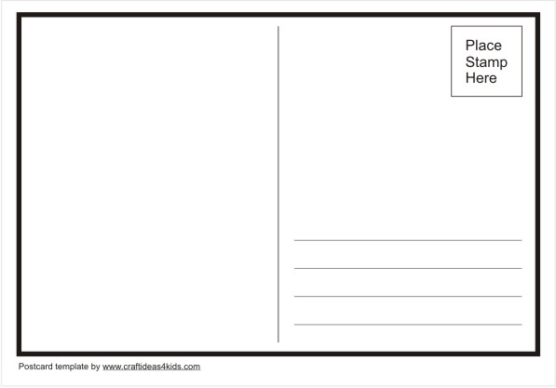

**Burleson County Elections Administration**

**Attn: Poll Worker Appointment Clerk**

**100 W. Buck St., Suite #107**

**Caldwell, TX 77836**